LLM Prompt Eval Registry Detailed DB Schema
Current migrated database and ORM intent
This reference separates the relationship picture from the field-level details. The diagram shows how records connect. The following dictionaries describe the actual migrated PostgreSQL columns and identify where SQLAlchemy model defaults or update behavior are not installed as database-level behavior.
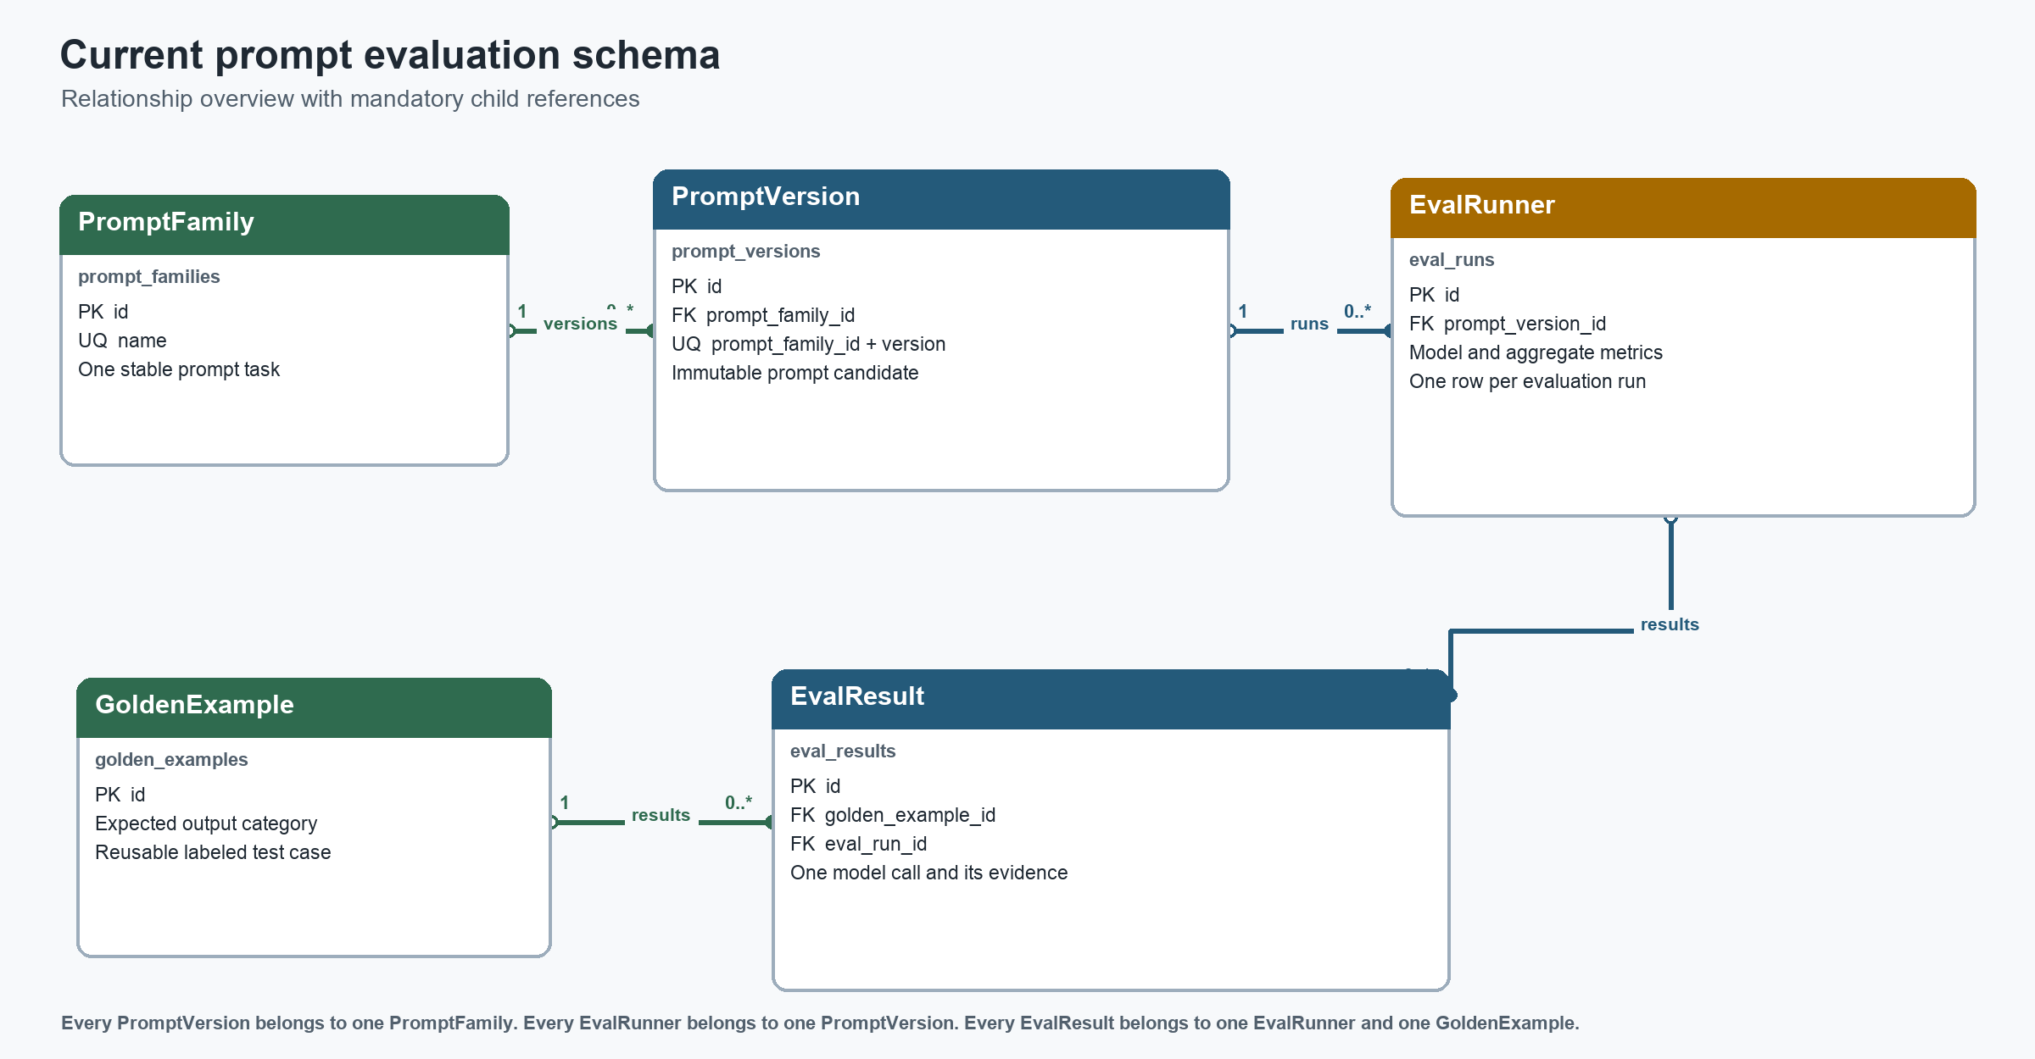

Relationship contract
Parent | Child | Cardinality | Required child reference | Foreign key | Deletion rule
prompt_families | prompt_versions | 1 to 0..many | Yes | prompt_versions.prompt_family_id | No explicit cascade
prompt_versions | eval_runs | 1 to 0..many | Yes | eval_runs.prompt_version_id | No explicit cascade
eval_runs | eval_results | 1 to 0..many | Yes | eval_results.eval_run_id | No explicit cascade
golden_examples | eval_results | 1 to 0..many | Yes | eval_results.golden_example_id | No explicit cascade

Evaluation trace
A result is fully traceable through eval_results.eval_run_id to one run, through eval_runs.prompt_version_id to the exact prompt text and version, and through prompt_versions.prompt_family_id to the stable task family. The result also points to the golden example used for ground-truth comparison.
- PromptFamily identifies the long-lived task.
- PromptVersion identifies one immutable prompt candidate inside that task.
- EvalRunner records one model evaluation and its aggregate metrics.
- EvalResult records one example-level response, normalization, score, cost, latency, and failure state.
- GoldenExample supplies the labeled input and expected category.

ORM navigation
- PromptFamily.prompt_versions pairs with PromptVersion.prompt_family.
- PromptVersion.eval_runners pairs with EvalRunner.prompt_version.
- EvalRunner.eval_results pairs with EvalResult.eval_run.
- GoldenExample.eval_results pairs with EvalResult.golden_example.

Prompt registry tables
prompt_families stores one stable task identity per allowed prompt-family name.
Column | PostgreSQL type | Nullable | Default behavior | Integrity | Meaning
id | INTEGER | No | None | Primary key | Surrogate family identifier
name | VARCHAR | No | None | CHECK + UNIQUE | PromptFamilyEnum member name
created_at | TIMESTAMPTZ | No | No DB default | - | Model declares server_default now()
updated_at | TIMESTAMPTZ | No | No DB default | - | ORM onupdate; no database trigger

Family identity behavior
name is both enum-checked and unique. SQLAlchemy stores enum member names, such as SUPPORT_TICKET_TRIAGE, because no values_callable mapping is configured. The current check constraint therefore protects the controlled family vocabulary while the unique constraint prevents duplicate family rows.

Prompt version table
prompt_versions stores immutable prompt candidates. The family plus version label forms the business identity; the integer id remains the relational key used by evaluation runs.
Column | PostgreSQL type | Nullable | Default behavior | Integrity | Meaning
id | INTEGER | No | None | Primary key | Surrogate version identifier
text | TEXT | No | None | - | Complete prompt text
version | VARCHAR | No | None | Composite unique | Semantic version label such as 1.0.0
is_active | BOOLEAN | Yes | ORM default false | - | Database still permits NULL
prompt_family_id | INTEGER | No | None | Foreign key | References prompt_families.id
created_at | TIMESTAMPTZ | No | No DB default | - | Model declares server_default now()
updated_at | TIMESTAMPTZ | No | No DB default | - | ORM onupdate; no database trigger

Evaluation run table
eval_runs stores aggregate measurements for one prompt version evaluated with one model. The class is still named EvalRunner, although the row represents a run rather than the runner application service.
Column | PostgreSQL type | Nullable | Default behavior | Integrity | Meaning
id | INTEGER | No | None | Primary key | One complete evaluation run
p95_latency_ms | DOUBLE PRECISION | No | ORM default 0.0 | - | Run-level p95 latency in milliseconds
accuracy | DOUBLE PRECISION | No | ORM default 0.0 | - | Scale is not yet constrained
average_cost | DOUBLE PRECISION | No | ORM default 0.0 | - | Currency and precision remain implicit
model_used | VARCHAR | No | None | - | Model identifier used by the run
prompt_version_id | INTEGER | No | None | Foreign key | References prompt_versions.id
created_at | TIMESTAMPTZ | No | No DB default | - | Model declares server_default now()
updated_at | TIMESTAMPTZ | No | No DB default | - | ORM onupdate; no database trigger

Golden example table
golden_examples stores reusable labeled inputs for deterministic support-ticket classification evaluation.
Column | PostgreSQL type | Nullable | Default behavior | Integrity | Meaning
id | INTEGER | No | None | Primary key | Labeled example identifier
input | VARCHAR | No | None | - | Support ticket text
expected_output | VARCHAR | No | None | CHECK | SPT, BUG, FEAT, or BILL
is_active | BOOLEAN | No | No default | - | Caller must provide a value
created_at | TIMESTAMPTZ | No | No DB default | - | Model declares server_default now()
updated_at | TIMESTAMPTZ | No | No DB default | - | ORM onupdate; no database trigger

Golden dataset note
The project currently contains 100 balanced examples, with 25 records for each output category. The table does not yet identify a dataset name or dataset version, so a later run cannot prove which revision of the golden set was used without an additional dataset model or run snapshot.

Evaluation result table
eval_results is the evidence table. It stores the input snapshot, raw provider response, normalized category, correctness, failure status, tokens, latency, cost, and the two mandatory parent references.

Identity output and usage fields
Column | PostgreSQL type | Nullable | Default behavior | Integrity | Meaning
id | INTEGER | No | None | Primary key | One evaluated example
input | VARCHAR | No | None | - | Snapshot of the evaluated input
predicted_category | VARCHAR | Yes | None | CHECK | Normalized category used for scoring
raw_output | TEXT | Yes | None | - | Unmodified provider response
input_tokens | INTEGER | No | ORM default 0 | - | Prompt token count
output_tokens | INTEGER | No | ORM default 0 | - | Completion token count
total_tokens | INTEGER | No | ORM default 0 | - | Not database-derived or constrained
passed | BOOLEAN | No | None | - | Correctness after normalization

Evaluation result measurement and traceability fields
Column | PostgreSQL type | Nullable | Default behavior | Integrity | Meaning
latency_ms | INTEGER | Yes | ORM default 0 | - | Individual request latency
cost | DOUBLE PRECISION | No | ORM default 0.0 | - | Currency and precision remain implicit
error_message | TEXT | Yes | None | - | Provider or parsing error detail
status | VARCHAR | No | None | CHECK | Outcome independent of correctness
golden_example_id | INTEGER | No | None | Foreign key | References golden_examples.id
eval_run_id | INTEGER | No | None | Foreign key | References eval_runs.id
created_at | TIMESTAMPTZ | No | No DB default | - | Model declares server_default now()
updated_at | TIMESTAMPTZ | No | No DB default | - | ORM onupdate; no database trigger

Status and correctness
status reports whether the request and parser completed. passed reports whether a valid normalized prediction matched the expected category. A completed result can still be incorrect. INVALID_OUTPUT, MODEL_ERROR, and TIMEOUT require an explicit evaluation policy for whether they count in the accuracy denominator.

Enums and constraints

OutputCategories
Stored member | Meaning | Used by
SPT | Support ticket | golden_examples.expected_output and eval_results.predicted_category
BUG | Bug | golden_examples.expected_output and eval_results.predicted_category
FEAT | Feature request | golden_examples.expected_output and eval_results.predicted_category
BILL | Billing | golden_examples.expected_output and eval_results.predicted_category

EvalResultStatusEnum
Stored member | Meaning
COMPLETED | The provider call and output parsing completed.
INVALID_OUTPUT | The model returned a response that could not be normalized to one category.
MODEL_ERROR | The provider or model request failed.
TIMEOUT | The model request exceeded the allowed time.

PromptFamilyEnum
Allowed stored member | Allowed stored member | Allowed stored member
SUPPORT_TICKET_TRIAGE | SUPPORT_REPLY_GENERATION | TICKET_SUMMARIZATION
TICKET_PRIORITY_CLASSIFICATION | TICKET_ROUTING | SENTIMENT_ANALYSIS
CUSTOMER_INTENT_CLASSIFICATION | TICKET_ENTITY_EXTRACTION | DUPLICATE_TICKET_DETECTION
ESCALATION_DETECTION | URGENCY_DETECTION | LANGUAGE_DETECTION
RESPONSE_QUALITY_EVALUATION | RESPONSE_TONE_EVALUATION | KNOWLEDGE_BASE_SEARCH_QUERY

Named identity constraints
Constraint | Table | Columns | Purpose
uq_prompt_families_name | prompt_families | name | One row per prompt family
uq_prompt_versions_family_version | prompt_versions | prompt_family_id, version | No duplicate version label inside one family
fk_eval_results_eval_run_id | eval_results | eval_run_id | Attach result to its run
fk_eval_results_golden_example_id | eval_results | golden_example_id | Attach result to its ground truth

Database behavior and remaining drift
The following items are intentionally explicit because a model declaration and an applied PostgreSQL schema are not automatically identical.
Area | Current database behavior | Model or application intent | Recommended resolution
Timestamps | NOT NULL columns have no persistent server default in the migration chain | Models declare server_default=now() | Add a migration that installs server defaults if database-side inserts must work
updated_at | No update trigger | onupdate=func.now() runs through SQLAlchemy | Keep ORM ownership or add a PostgreSQL trigger; document the choice
Metric defaults | No server defaults | SQLAlchemy defaults several counters and floats to zero | Require service values or add explicit server defaults where zero is meaningful
Prompt activation | is_active may be NULL and multiple versions may be active | ORM default false | Make non-null and add a partial unique index for one active version per family
Cost | DOUBLE PRECISION with implicit currency | Track average and per-result cost | Use fixed-precision Numeric and explicit names such as cost_usd
Accuracy | DOUBLE PRECISION without a range constraint | Aggregate classification quality | Choose 0-1 or 0-100 and add a CHECK constraint
Deletion | Foreign keys have no explicit cascade | Historical traceability should be preserved | Use restrictive deletion or soft deletion for prompt and evaluation history
Indexes | Unique constraints are indexed; FK indexes are not explicitly defined | Frequent joins will use four FK paths | Add indexes after checking query plans and expected access patterns

Recommended query indexes
Likely join indexes are prompt_versions.prompt_family_id, eval_runs.prompt_version_id, eval_results.eval_run_id, and eval_results.golden_example_id. Add them after checking expected access patterns and PostgreSQL query plans.

